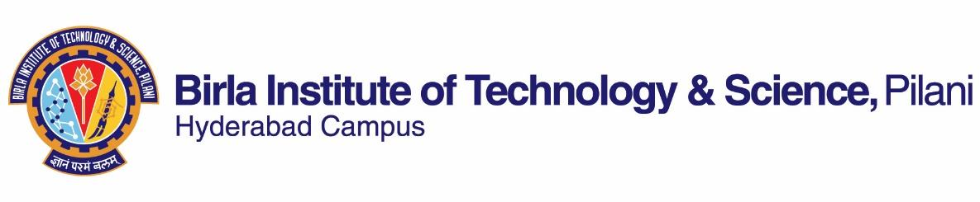

**SECOND SEMESTER 2023-2024**

# Course Handout Part II

Date: 09-01-2024

In addition to part-I (General Handout for all courses appended to the time table) this portion gives further specific details regarding the course.

*Course No.* : HSS F316

## Course Title : Popular Literature and Culture of South Asia

## Instructor-in-Charge : Prof. Maya Vinai

**Scope and Objective of the Course:** The objective of the course is to introduce students to Literature and Popular Culture of South Asia. In doing so, it will familiarize students to perspectives and scenarios that differ from their own culture, thereby, helping them to have deeper understanding of other cultures. This course aims to bridge the gaps in our understanding of our neighbors and enable us to have broader perspectives

**Textbooks:**

1. Betts, Raymond & Lyz Bly F. *A History of Popular Culture (2nd edition).* New York: Routledge, 2013.

**Reference books**

1. Hamid, Mohsin. *The Reluctant Fundamentalist*. Florida: Harcourt Publishers, 2007
2. Hosseini Khalid. *And the Mountains Echoed.* London: Bloomsbury, 2014.
3. Narula, Devika Khanna*. South Asian Diaspora: Sumer Blossoms in Winter Garden.* New Delhi: Cr New Delhi: Creative, 2005.
4. Selvadurai, Shyam. *Many Roads to Paradise: An Anthology of Sri Lankan Literature.* New Delhi: Penguin, 2014.
5. Vora, Neha. *Impossible Citizens.* New Delhi: Orient Blackswan, 2013
6. Zaman, Niaz. *Literature in Bangladesh: Selected Short Stories from Bangladesh.* Dhaka: UPL, 2007.
7. Chambers, Claire. *Desi Delicacies: Food Writing from Muslim South Asia.* New Delhi: Picador, 2013.
8. Manivannan, Sharanya. *Incantations Over Water*. New Delhi: Context, 2021.

**Web Sources:**

https://core.ac.uk/download/58757146.pdf

**Course Plan:**

| **Lecture No.** | **Learning Objectives** | **Topics to be covered** | **Reference to Chap/Sec/Book** |
| --- | --- | --- | --- |
| 1 | Introductory Class | Introduction to the paper | Class Notes |
| 2-6 | Examine the political, social, cultural and economic configuration of South Asian countries. | South Asia as a region  Geographical boundaries, political, economic and societal features.  Major religious diversities of these South Asian countries.  The connotations of the term ‘popular culture’ & its features. | Reading Material.  (T.B Chapter 1 & 2) |
| 7-13 | Analyze and interrogate the racial stereotypes. | The concept of ethnic majority and minority, power divide and unequal distribution of resources  Understanding Afghanistan through literature | Selected Readings from R.B 2. |
| 14-20 | Analyze the representational strategies post 9/11 attacks | The politics of representation and breaking of stereotypes.  Understanding Pakistan through literature.  Media Framing, Islamaphobia & the creation of East-West Binary | Selected Readings- Mohsin Hamid’s *The Reluctant Fundamentalist*  (R.B 1) |
| 21- 26 | Examine partition and trauma of dislocation in fiction. | Violence, migration and dislocation.  Understanding Liberation war of 1971 and Bangladeshi culture through literature. | (R.B 7) |
| 27-32 | Discuss the concept of Nation-building in films | Culture and its representation through literature and cinema. Nation/ *Desh Videsh* dichotomy and the representation of NRI in Bollywood and South Asian cinema and fictional works. | Class notes and handouts. |
| 33- 38 | Discuss the ethnic divide (Sinhala- Tamil) and specificities of Srilankan culture. | Identity Formation and Assertion,  Commonalities in spite of all the differences (culture, rituals, gender binaries) | (R.B – 4 or 8)  Selected short stories from Sri Lanka. |
| 39-42 | Analyze marginalization on account of ethnicity and gender and resistance by the subalterns. | Bringing in marginalized voices &  Writings by women  Poems from Afghanistan (Landays), women in private and public sphere | Selected South Asian Films & Advertisements  &  Class Notes |  |  | Selected *Landays* |

**Evaluation Scheme:**

|  |  |  |  |  |
| --- | --- | --- | --- | --- |
| **Component** | **Duration** | **Weightage (%)** | **Date & Time** | **Nature of Component** |
| Mid Semester Exam | 2 hours | 30% | 12/03 - 4.00 - 5.30PM | Closed Book |
| Assignment/ Quiz/ Presentations (2) | 40 mins | 30% | Will be Announced | Open Book |
| Comprehensive Exam | 3 hours | 40% | 09/05 AN | Closed Book |

**Chamber Consultation:** A Google Meet link along with consultation hours will be shared on the CMS

Notices: Will be put up on CMS//alternative learning management system

**Make-up Policy**: Make ups will be granted only for exceptionally deserving cases and should be communicated at least 2 hours before the missed component along with sufficient evidence.

**Academic Honesty and Integrity Policy:** Academic honesty and integrity are to be maintained by all the students throughout the semester and no type of academic dishonesty is acceptable.

**Dr. Maya Vinai**

**INSTRUCTOR-IN-CHARGE**